Theoretical Analysis

Insertion Sort

Best Case: n^2
Worst Case: n^2
Average Case: n^2

Merge Sort

Best Case: nlogn
Worst Case: nlogn
Average Case: nlogn

Quick Sort

Best Case: n^2
Worst Case: n^2
Average Case: n^2

Heap Sort

Best Case: nlogn
Worst Case: nlogn
Average Case: nlogn

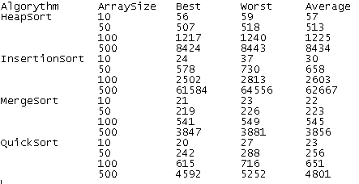

Actual Analysis

Insertion Sort

Best Case: n^2
Worst Case: n^2
Average Case: n^2

Merge Sort

Best Case: nlogn
Worst Case: nlogn
Average Case: nlogn

Quick Sort

Best Case: nlogn
Worst Case: n^2
Average Case: nlogn

Heap Sort

Best Case: nlogn
Worst Case: n^2
Average Case: nlogn

